Smart Academic and Examination Management System (SAEMS)
Software Requirement Engineering (Lab)



Submitted by: Abdul Samad
Submitted to: Sir Fahim Muhammad Khan
Lab No. 5
Semester: V - BSSE (Group-A)
Use Case Modeling
Session 2024 –2028 (Fall)

INSTITUTE OF MANAGEMENT SCIENCES
HAYATABAD, PESHAWAR (2025)

Task 1 - Identify the System Boundary
System name: Smart Academic and Examination Management System (SAEMS).
Inside the boundary: The SAEMS use cases that support academic and examination activities, including course registration, course dropping, timetable and examination schedule viewing, instructor work, coordinator work, examination work, and administrator functions.
Outside the boundary: The actors that interact with SAEMS. The scenario specifically mentions the Identity Authentication Service and Bank Payment Gateway as external systems. The human actors are also outside the boundary.

Task 2 - Identify Actors

Actor | Type | Reason for Interaction
Student | Primary, human | Uses SAEMS for course search, registration, dropping courses, timetable and examination schedule.
Course Instructor | Primary, human | Uses SAEMS to view assigned courses and students, upload materials, submit attendance and enter marks.
Department Coordinator | Primary, human | Manages course offerings, instructor assignments and special registration/drop requests.
Examination Officer | Primary, human | Creates examination schedules, assigns rooms, publishes the timetable and records results.
System Administrator | Primary, human | Manages accounts, roles, permissions, configuration and system reports.
Identity Authentication  Service | Secondary, external system | Used when a user logs in and when password recovery is needed.
Bank Payment Gateway | Secondary, external system | Processes the student's outstanding dues payment and returns the payment result.

Task 3 - Identify Actor Goals / Candidate Use Cases

Actor | Candidate Goal / Use Case
Student | Search Courses  View Course Details  Register for Course  Drop Course  View Timetable  View Examination Schedule
Course Instructor | View Assigned Courses  View Registered Students  Upload Lecture Materials  Submit Attendance  Enter Internal Marks
Department Coordinator | Manage Course Offerings  Assign Instructors to Courses  Review Special Registration  Review Special Drop Request
Examination Officer | Create Examination Schedule  Assign Examination Rooms  Publish Examination Timetable  Record and Release Results
Actor | Candidate Goal / Use Case
System Administrator | Manage User Accounts  Manage Roles and Permissions  Configure System  Generate System Reports
University User (all five human roles) | Log In

Task 4 - Draw the Basic Use Case Diagram
The supplied StarUML model is included below as the diagram used for this report.
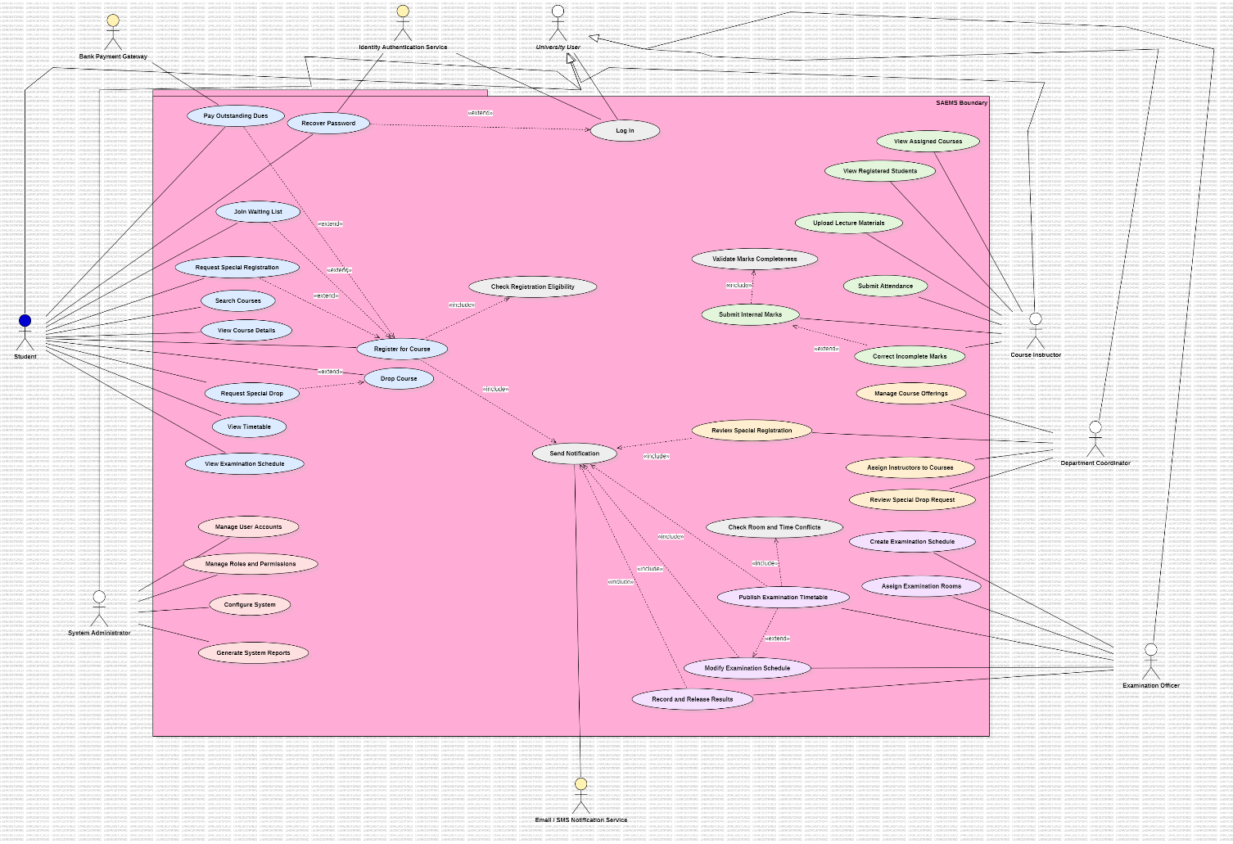

Task 5 - Analyze «include» and «extend»
The relationships below follow the completed model. «include» is used for behavior that is required as part of the base use case. «extend» is used where the extra behavior happens only in a particular condition.

Extension | Base |  | Condition
Recover Password | Log In |  | Student forgot password
Join Waiting List | Register for Course |  | Course is full
Pay Outstanding Dues | Register for Course |  | Student has dues
Request Special Registration | Register for Course |  | Prerequisites missing
Submit Special Drop Request | Drop Course |  | Deadline has passed
Modify Examination Schedule | Publish Examination Timetable |  | Room or time conflict found
Base |  | Included
Register for Course |  | Check Registration Eligibility (prerequisites and seats)
Enter Internal Marks |  | Validate Marks Completeness
Publish Examination Timetable |  | Check Schedule Conflicts

These checks are kept as separate included use cases in the model. They could also be written as steps inside the fully dressed use case, but the important point is to keep the chosen approach consistent.

Task 6 - Consider Generalization
An abstract actor called University User is used for the five human roles. Student, Course Instructor, Department Coordinator, Examination Officer and System Administrator inherit the shared Log In use case from this general actor.
This also handles the case where one person performs more than one university role: the person can act through the relevant specialized actor roles.

Task 7 - Review the Model Like a Requirements Analyst
System boundary is clearly defined.
Actors are outside the system boundary.
Use cases are inside the system boundary.
Use case names describe meaningful goals.
Each actor has a reason for interacting with SAEMS.
User-interface actions are not used as separate use cases.
«include» relationships are used for required checks.
«extend» relationships are used for conditional or optional behavior.
Relationship directions and labels are shown in the diagram.
The diagram is kept as the supplied model rather than adding unrelated features.

Task 8 - Write One Use Case Description

Use Case Name | Register for Course
Primary Actor | Student
Goal | Register for a selected course successfully through SAEMS.
Preconditions | The student is logged in and has selected a course to register for.
Main Success Scenario | - The student starts the course registration.  - SAEMS checks the student's identity, prerequisites and available seats.  - The registration is completed when the required checks are satisfied.  - SAEMS generates a registration confirmation.  - SAEMS updates the student's timetable.
Alternative / Exception Flows | If the course is full, the student may join the waiting list. If the student has outstanding dues, the dues are paid through the Bank Payment Gateway before registration is completed. If prerequisites are missing, the student may submit a special registration request.
Postconditions | The student is registered for the course and the timetable is updated.

Lab Reflection Questions
- What is the difference between an actor and a user?
An actor is an external entity that interacts with the system to achieve a goal. A user is a person who uses the system. In a use case model, an actor can also be another system or an external service.
- Why must actors normally be outside the system boundary?
The boundary shows what belongs to the system being modeled. Actors are outside because they interact with the system rather than being part of the system itself.
- Why is “Register for Course” a stronger use case candidate than “Click Register Button”?
“Register for Course” describes a meaningful goal the student wants to complete. “Click Register Button” is only a user-interface action.
- What is the practical difference between «include» and «extend»?
«include» is used when the included behavior is required as part of the base use case. «extend» is used when extra behavior happens only under a condition or is optional.
- What mistake would occur if every system function were treated as a separate use case?
The model would contain too many small and unnecessary use cases. It would become harder to read and would mix internal system activities with meaningful user goals.
- How does a Use Case Diagram differ from a fully dressed Use Case?
A use case diagram shows actors, use cases and their relationships at a high level. A fully dressed use case gives more detail about one use case, such as its actor, goal, preconditions, main steps, alternatives and postconditions.
7. What information does a Use Case Diagram intentionally leave out?
It leaves out the detailed step-by-step flow, alternative flows, preconditions and postconditions of each use case. Those details are written in the fully dressed use case.

Key Takeaway
Use case modeling focuses on who interacts with the system, what meaningful goals they want to achieve, and how those interactions are represented at a high level.

